Raise a Share Link Dispute in Numero System Test, via Log Manual Process;

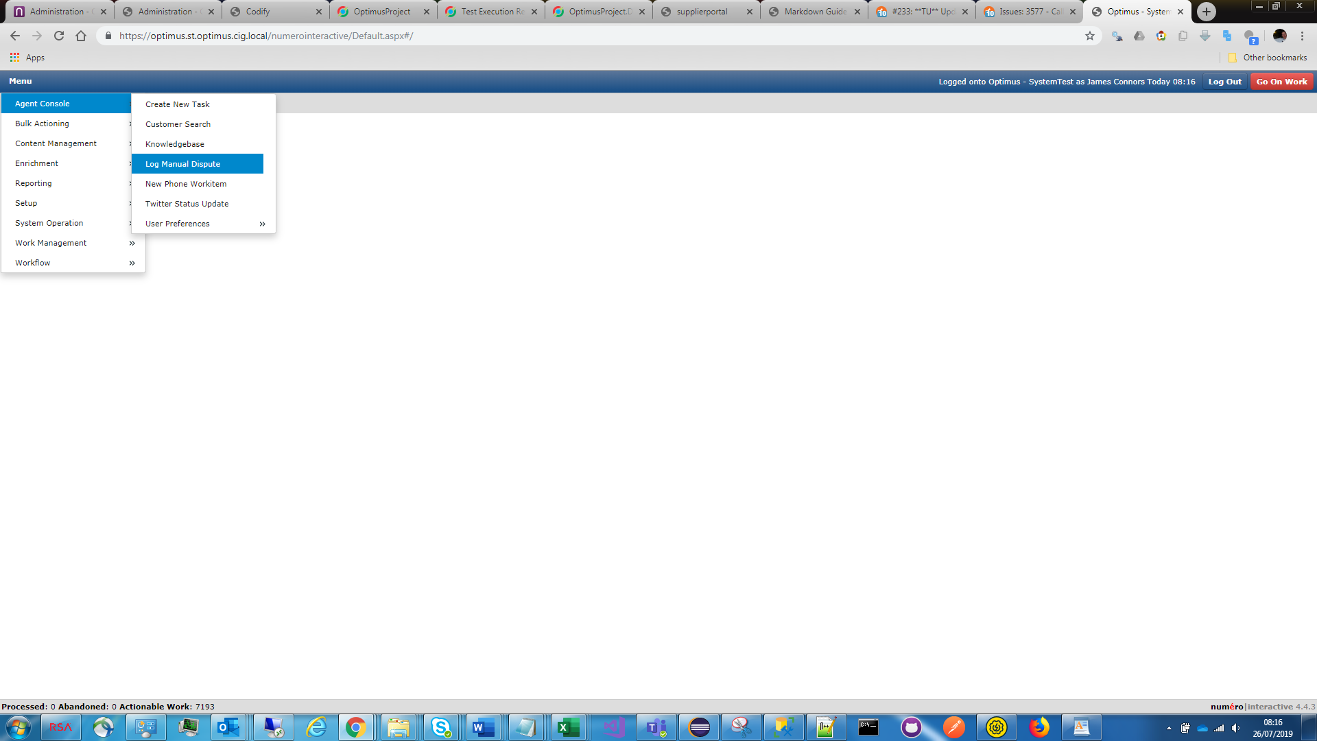

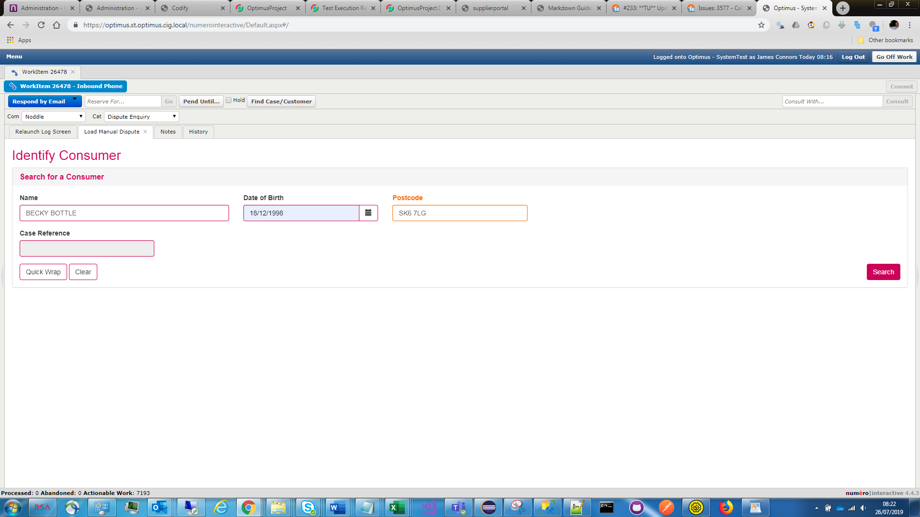

This is present pick list showing current and previous addresses (note for test purposes the consumer current and previous addresses are at same postcode);

Address selected, dispute date entered and ID&V answered;

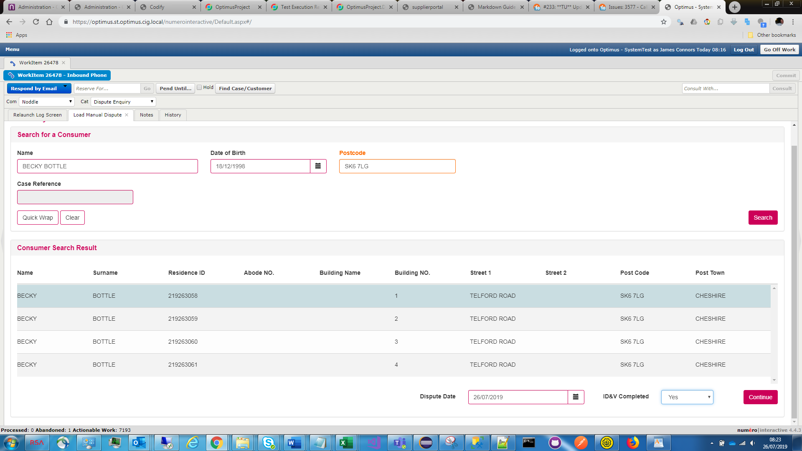

Case Linking window presented,

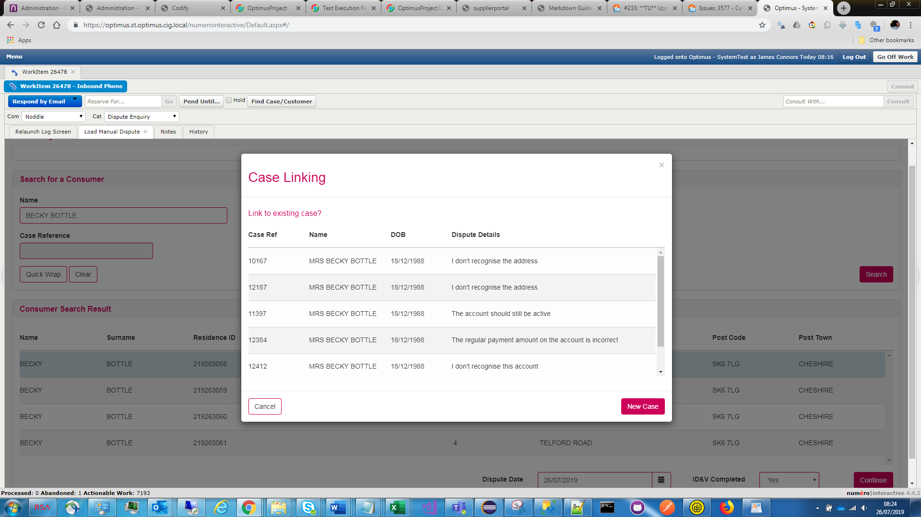

New Case clicked

Credit Report displayed, with sections collapsed;

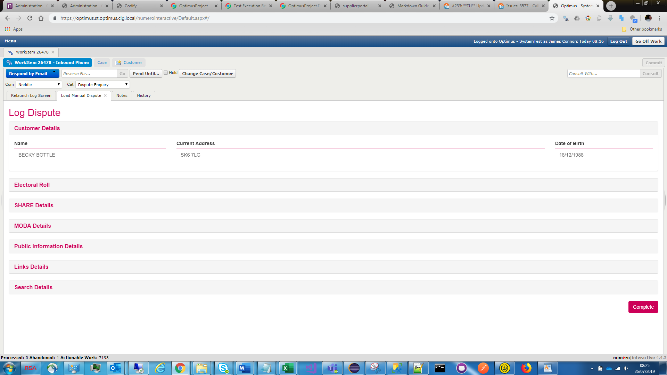

SHARE Details expanded so I can raise a dispute;

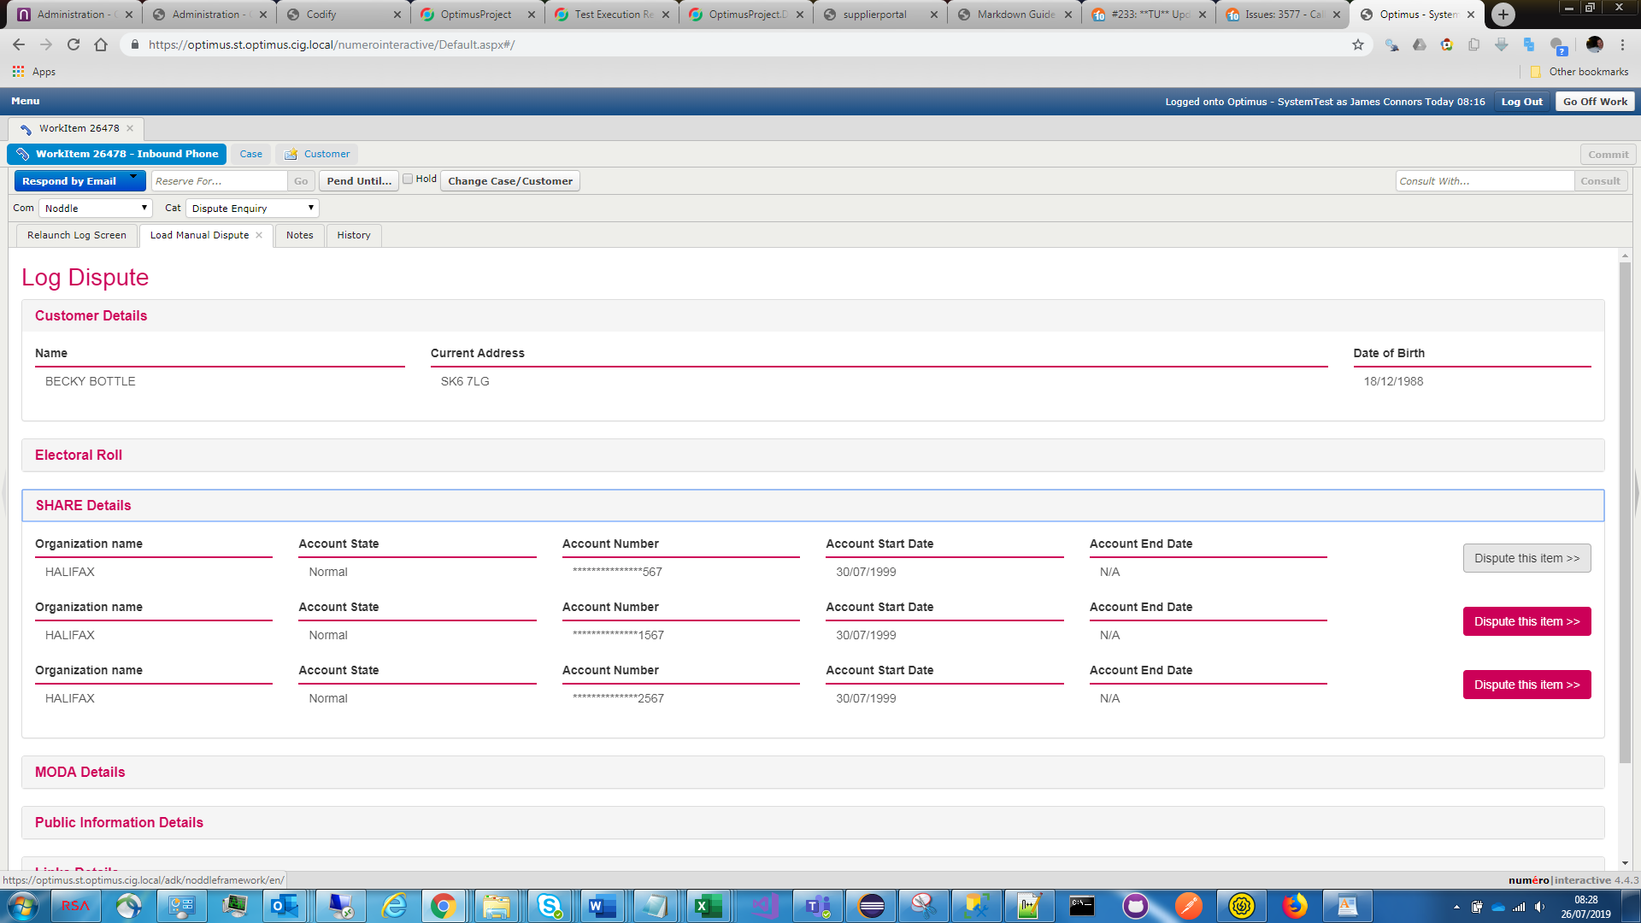

Click Dispute this item button and enter details;

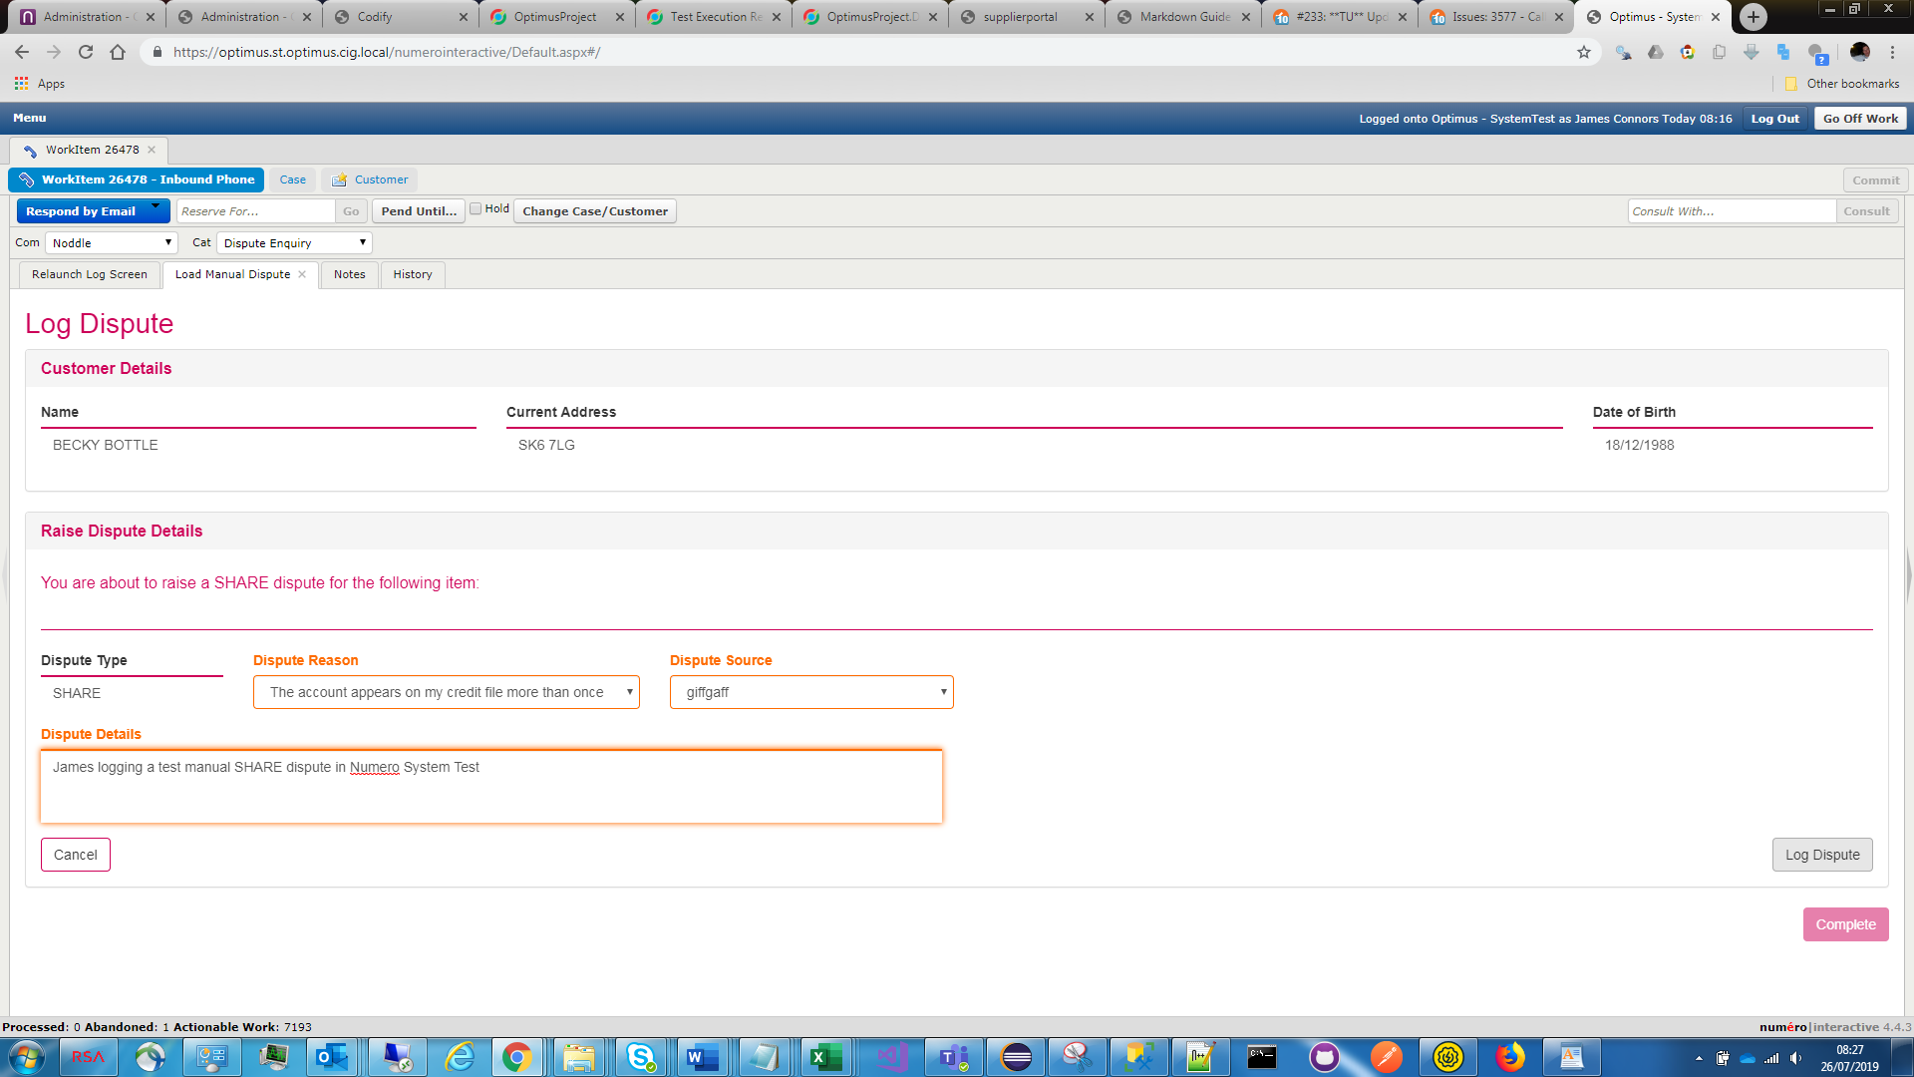

Click Log Dispute;

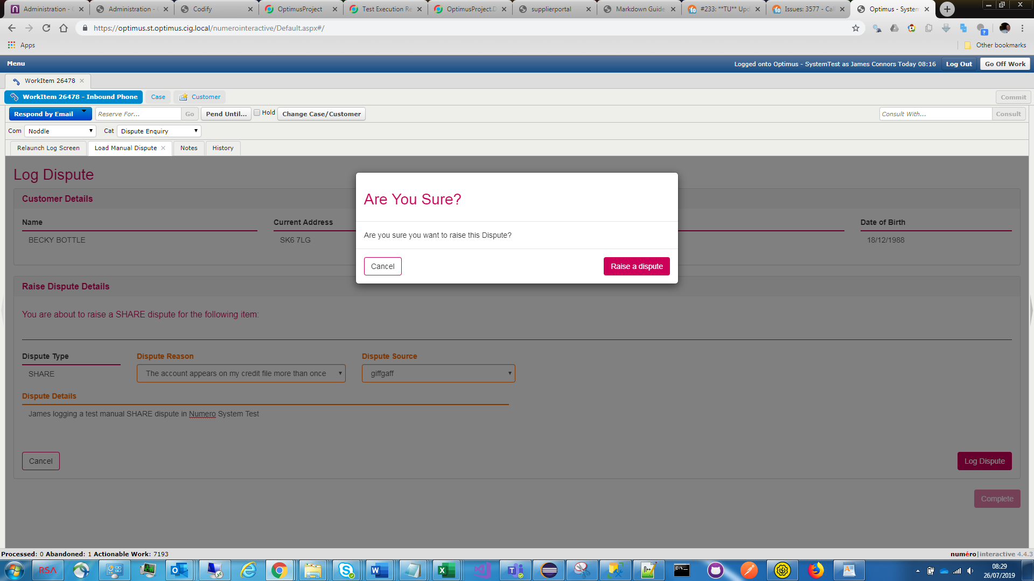

Click Raise a dispute, returned to the Credit Report;

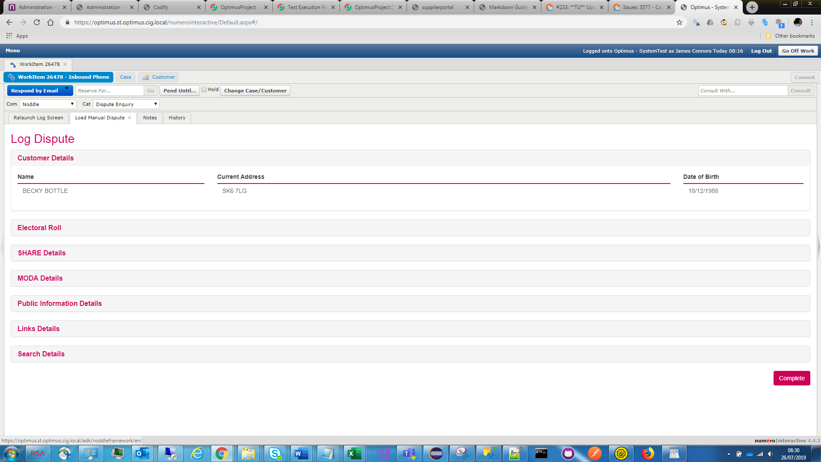

I can see in the Numero Database that the dispute has been created with Dispute Case Id of 4369, which is Awaiting Submission and will be processed in 10 mins;

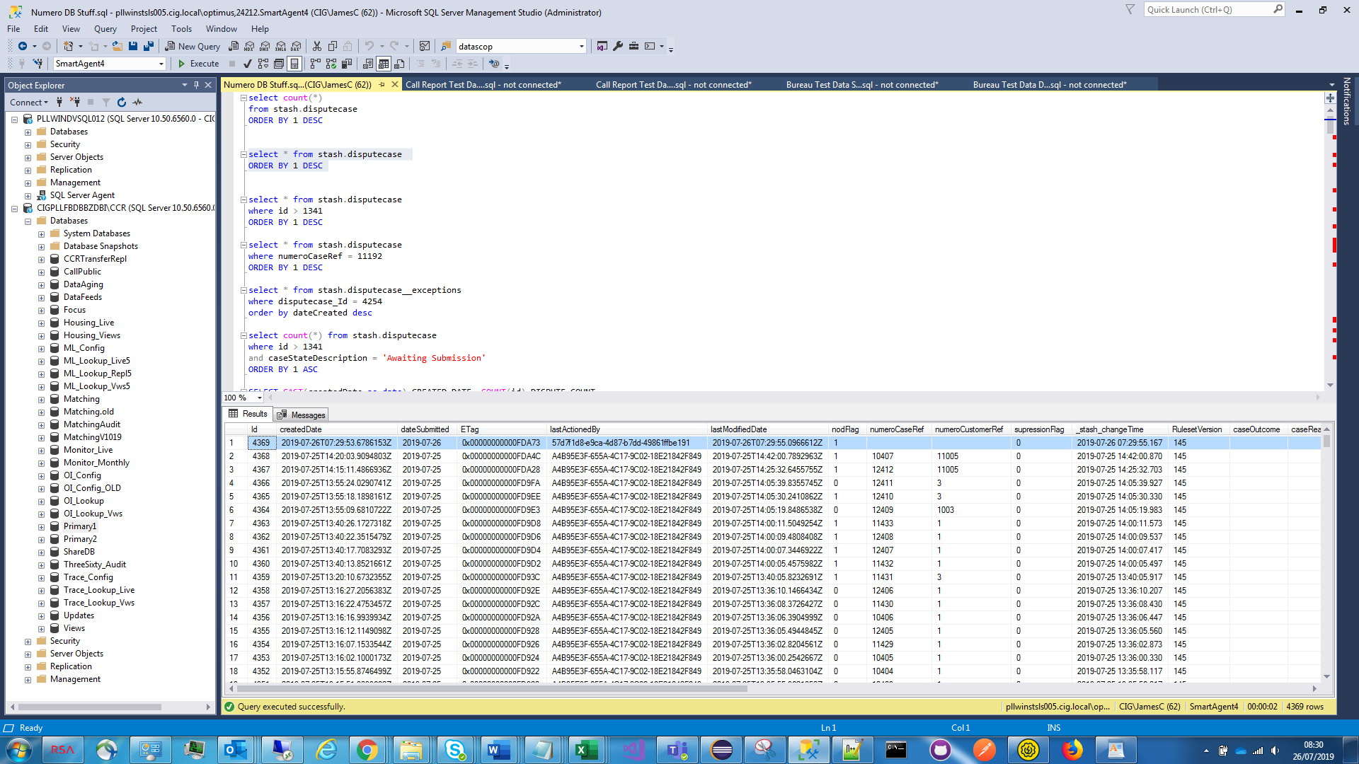

In Numero database the NOD and Suppression sproc calls are recorded in stash.dataupdatequeue showing the dataupdatequeue record that maps to the dispute case id. The parameters sent to the with the sproc call are stored in stash.dataupdatequeue__storedProcedureParameters

The following shows highlighted the calls to the add nod sproc (dataUpdateType 3 indicated call to add NOD, 4 is remove NOD, 1 is add suppression and 2 is remove suppression)

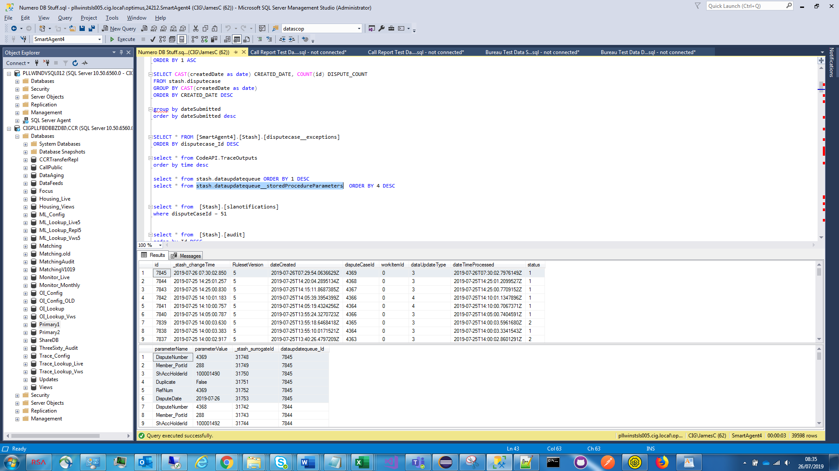

10 minute Numero linking incoming cases waiting period has elapsed and the case has been processed with a status of ‘Awaiting Supplier’ as it has been auto routed through to the Supplier Portal, which means that a datascope was successfully derived from the member port ID associated with the SHARE credit report line item;

